Project Report
Louis Needs
M00571563

This project is designed for us as students to create a fully functioning single pager website. We must implement data storage, in which the data can be stored and retrieved from the database, as well as successful use of JavaScript running on Node.js to deliver functionality of the website. Client-side JavaScript will also be implemented to increase complexity of the website. This single page website must consist of only one html page, and no php.
The purpose of this project is to build a fully functioning single page web application, the proves easy and comfortable to navigate as well as providing a chat service for users to post comments, questions and answers. The website I have decided to create is a chat-based website, in which users can talk to one another about cars, motorbike etc. I have decided on a white and grey colour scheme for simplicity yet appealing. Navigation is simple, and JavaScript is used throughout. The outcome when the project is completed is that users can chat within the ‘chat’ room and register and login and each person chats to each other.
The final outcome of the project resulted in less functionality than intended with partially working lines of codes and a login function with no chat service implemented.
Database.
MySQL is an open source database system, established in 1995 on the 23rd of May. allowing us to store data required for future uses on the web page.
The database will store an Email, username, and password and potentially users posted comments on the forum. This database will be created using MySQL and Node.js and AJAX for communication between the Node.js server and web application.

During this project third party libraries were used such as:

- Bootstrap (grid layout).
- Cross origin resource sharing (CORS) ? (included, just in case).
- NPM package manager (included just incase).

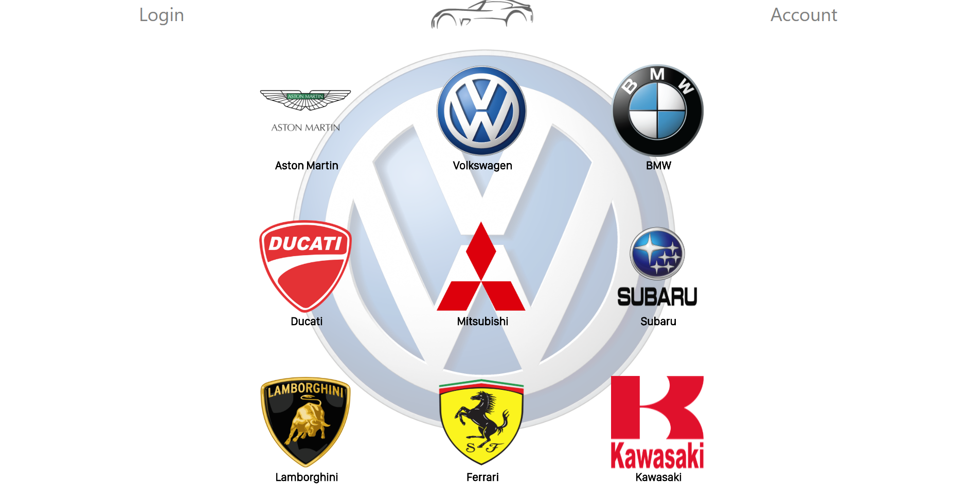
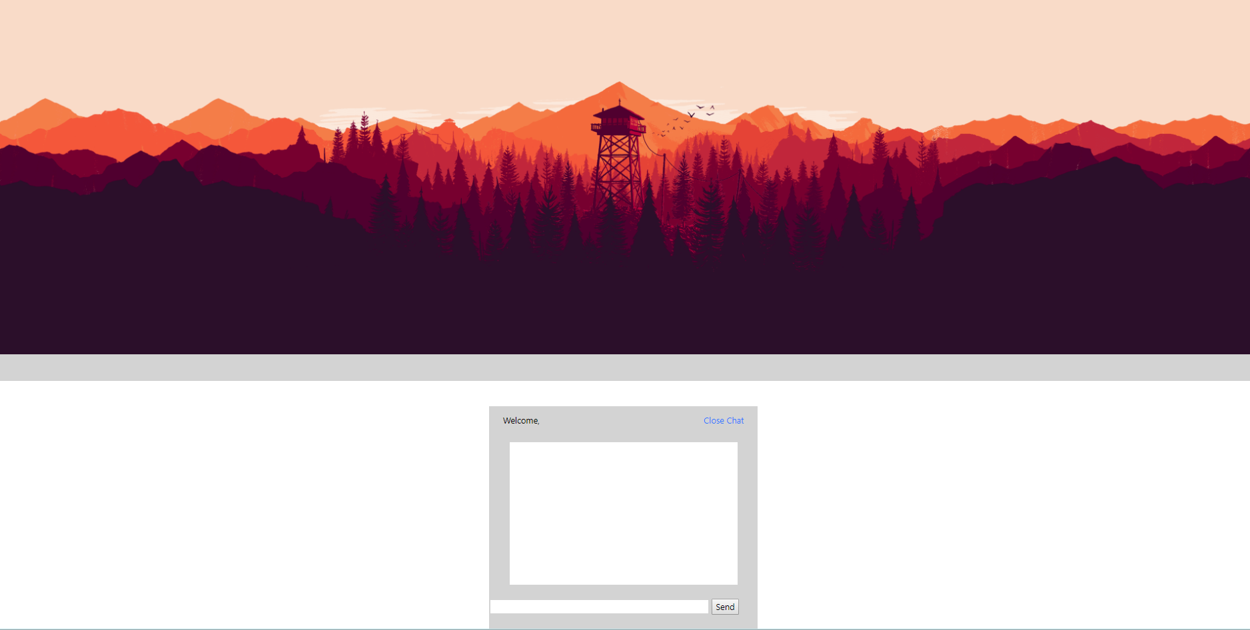
Screenshot one.

Screenshot two.

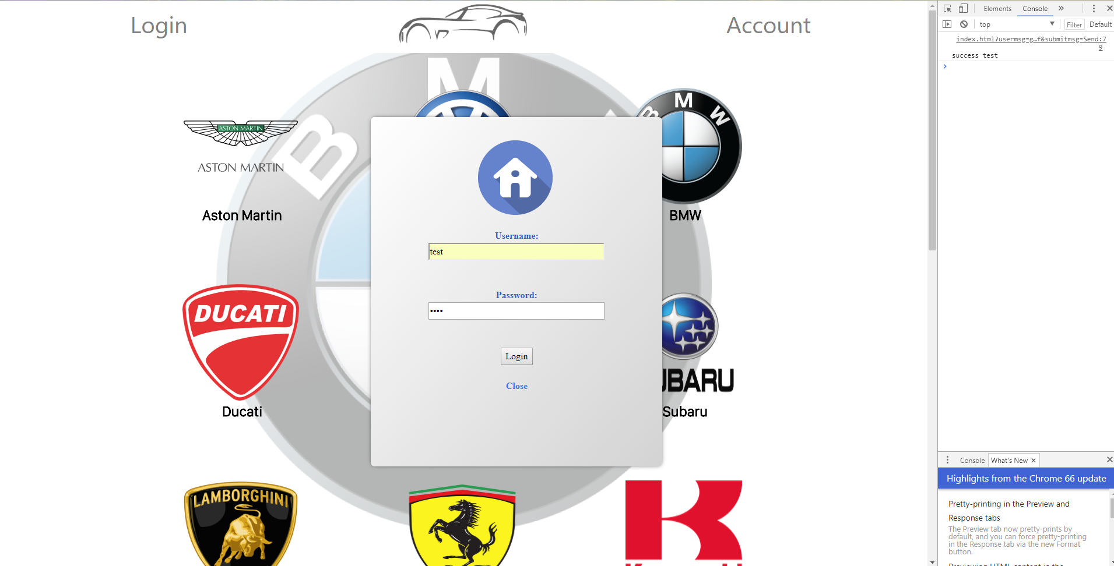
Showing a successful login, using a test.

